**Laboratory 5 – RIP routing protocols**

Student name: Phan Phương Duy Student ID: ITITIU16010

***Lab 5.1: RIP Configuration***

**Topology**



**IP Addressing**

**Requirement:**

LAN1: 192.x.1.0/24

LAN2: 192.x.3.0/24

Serial connection: 192.x.2.0/24

|  |  |  |  |  |
| --- | --- | --- | --- | --- |
| **Device** | **Interface** | **IP Address** | **Subnet Mask** | **Descriptions / Default Gateway** |
| **R1** | Fa0/0 | 192.168.1.1 | 255.255.255.0 | N/A |
| S0/0/0 | 192.168.2.1 | 255.255.255.0 | N/A |
| **R2** | Fa0/0 | 192.168.3.1 | 255.255.255.0 | N/A |
| S0/0/0 | 192.168.2.2 | 255.255.255.0 | N/A |
| Lo0 | 172.16.30.1 | 255.255.255.252 | connect to ISP |
| **PC1** | NIC | 192.168.1.2 | 255.255.255.0 |  |
| **PC2** | NIC | 192.168.3.2 | 255.255.255.0 |  |

**Learning Objectives**

Upon completion of this lab, you will be able to:

* Configure RIP routing on Cisco’s routers.
* Verify RIP routing using show and debug commands.
* Reconfigure the network to make it contiguous.
* Observe automatic summarization at boundary router.
* Gather information about RIP processing using the debug ip rip command.
* Configure a static default route.
* Propagate default routes to RIP neighbors.
* Document the RIP configuration.

**Task 1: Perform Basic Router Configurations.**

Perform basic configuration of the R1, and R2 routers according to the following guidelines:

1. Configure the router hostname.
2. Disable DNS lookup.
3. Configure an EXEC mode password.
4. Configure a message-of-the-day banner.
5. Configure a password for console connections.

**Task 2: Configure and Activate Serial and Ethernet Addresses.**

**Step 1: Configure interfaces on R1, and R2.**

Configure the interfaces on the R1, and R2 routers with the IP addresses from the table under theTopology Diagram.

**Step 2: Verify IP addressing and interfaces.**

Use the show ip interface brief command to verify that the IP addressing is correct and that the interfaces are active.

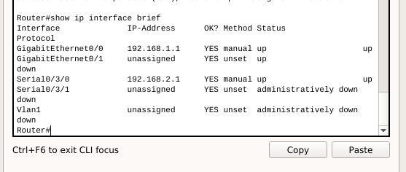

What is the directly connected networks of two routers?

network: 192.168.2.0

**Step 3: Configure Ethernet interfaces of PC1, and PC2.**

Configure the Ethernet interfaces of PC1, and PC2 with the IP addresses and default gateways from the table under the Topology Diagram.

**Step 4: Test the PC configuration by pinging the default gateway from the PC.**

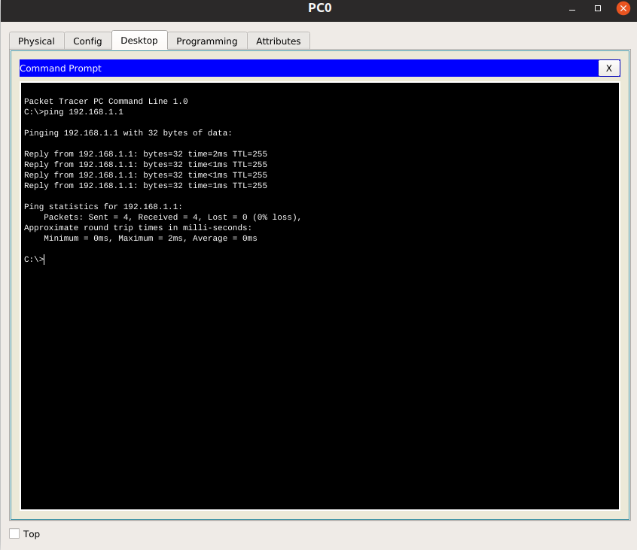

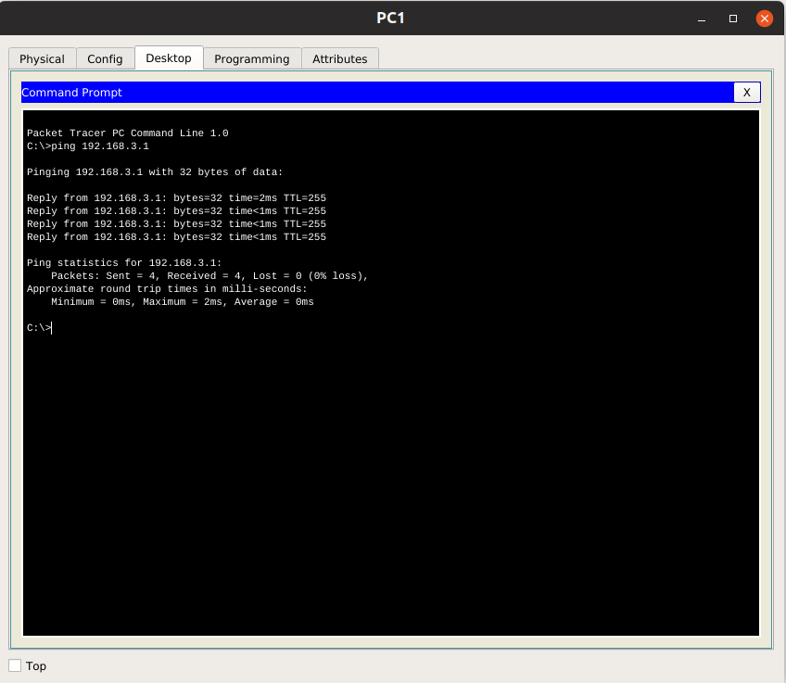

When you have finished, be sure to save the running configuration to the NVRAM of the router.

**Task 3: Configure RIP.**

**Step 1: Understanding RIP routing protocol and configure RIP on Cisco router**

* <http://www.cisco.com/c/en/us/td/docs/ios-xml/ios/iproute_rip/configuration/15-mt/irr-15-mt-book/irr-cfg-info-prot.html>
* <http://www.cisco.com/c/en/us/td/docs/ios/12_2/ip/configuration/guide/fipr_c/1cfrip.html>

**Step 2: Enable dynamic routing.**

To enable RIP, enter the command router rip in global configuration mode. Please read

R1(config)#router rip

R1(config-router)#

**Step 3: Enter classful network addresses.**

Once you are in routing configuration mode, enter the classful network address for each directly connected network, using the network command.

R1(config-router)#network 192.x.1.0

R1(config-router)#network 192.x.2.0

R1(config-router)#

What is the purpose of the network command?

Associates a network with a RIP routing process.

**Step 4: Configure RIP on the R2 router using the router rip and network commands.**

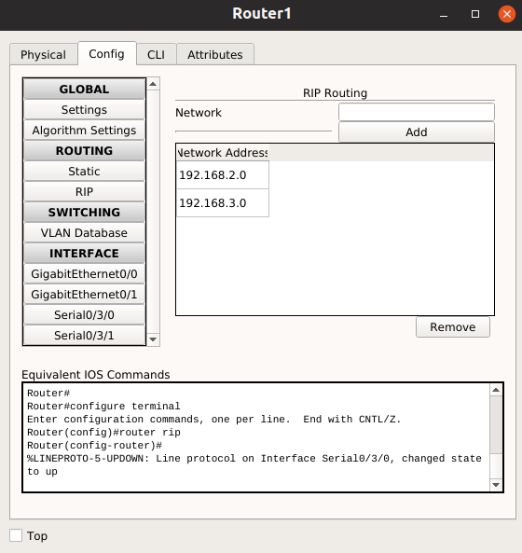

When you are finished with the RIP configuration, return to privileged EXEC mode and save the current configuration to NVRAM on both routers.

**Step 5: Show the output of show running-config command to your report.**

**Router 0:**

Router#show running-config

Building configuration...

Current configuration : 819 bytes

!

version 15.1

no service timestamps log datetime msec

no service timestamps debug datetime msec

no service password-encryption

!

hostname Router

!

!

!

!

!

!

!

!

no ip cef

no ipv6 cef

!

!

!

!

license udi pid CISCO2901/K9 sn FTX1524RMX3

!

!

!

!

!

!

!

!

!

!

!

spanning-tree mode pvst

!

!

!

!

!

!

interface GigabitEthernet0/0

ip address 192.168.1.1 255.255.255.0

duplex auto

speed auto

!

interface GigabitEthernet0/1

no ip address

duplex auto

speed auto

!

interface Serial0/3/0

ip address 192.168.2.1 255.255.255.0

clock rate 2000000

!

interface Serial0/3/1

no ip address

clock rate 2000000

shutdown

!

interface Vlan1

no ip address

shutdown

!

router rip

network 192.168.1.0

network 192.168.2.0

!

ip classless

!

ip flow-export version 9

!

!

!

!

!

!

!

line con 0

!

line aux 0

!

line vty 0 4

login

!

!

!

end

Router 1:

Router#show running-config

Building configuration...

Current configuration : 809 bytes

!

version 15.1

no service timestamps log datetime msec

no service timestamps debug datetime msec

no service password-encryption

!

hostname Router

!

!

!

!

!

!

!

!

no ip cef

no ipv6 cef

!

!

!

!

license udi pid CISCO2901/K9 sn FTX15247V1L

!

!

!

!

!

!

!

!

!

!

!

spanning-tree mode pvst

!

!

!

!

!

!

interface GigabitEthernet0/0

ip address 192.168.3.1 255.255.255.0

duplex auto

speed auto

!

interface GigabitEthernet0/1

no ip address

duplex auto

speed auto

shutdown

!

interface Serial0/3/0

ip address 192.168.2.2 255.255.255.0

!

interface Serial0/3/1

no ip address

clock rate 2000000

shutdown

!

interface Vlan1

no ip address

shutdown

!

router rip

network 192.168.2.0

network 192.168.3.0

!

ip classless

!

ip flow-export version 9

!

!

!

!

!

!

!

line con 0

!

line aux 0

!

line vty 0 4

login

!

!

!

end

**Task 4: Verify RIP Routing.**

**Step 1: Use the show ip route command to verify that each router has all of the networks in the topology entered in the routing table.**

Are the routing tables have the entries beginning with character ‘R’? If NOT, there is something wrong in the configuration.

Yes

Show the routing tables of two routers and please explain the entries in two routing tables.

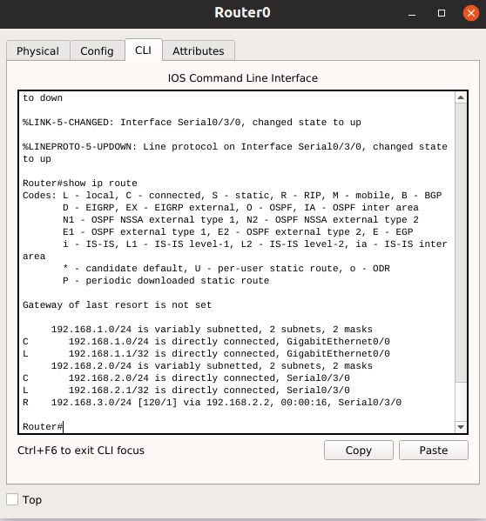

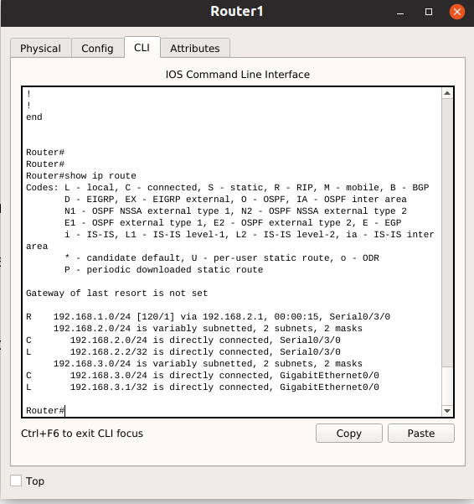

**Step 2: Use the show ip protocols command to view information about the routing processes.**

The show ip protocols command can be used to view information about the routing processes that are occurring on the router. This output can be used to verify most RIP parameters to confirm that:

* RIP routing is configured
* The correct interfaces send and receive RIP updates
* The router advertises the correct networks
* RIP neighbors are sending updates

Please list the output of show ip protocols command.

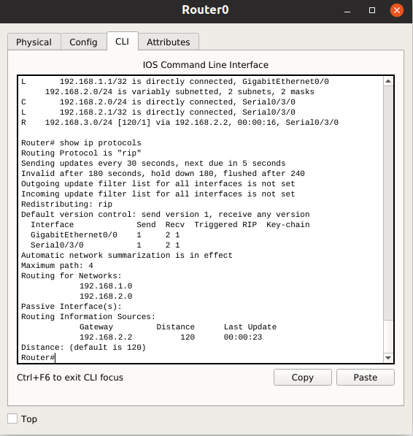

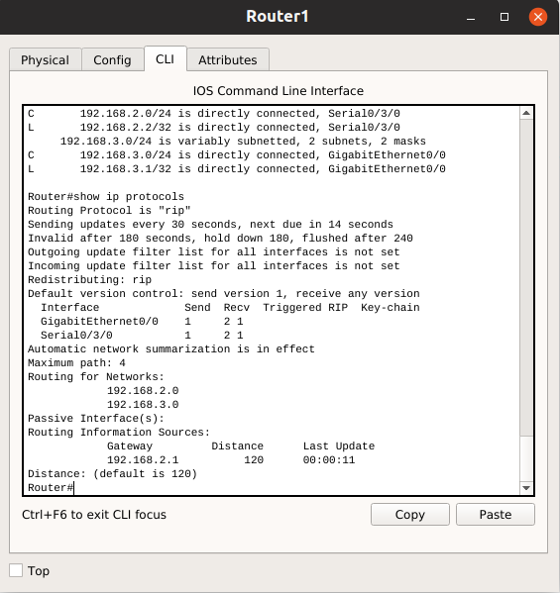

Please understand and explain in details the meaning of the above outputs. For example the timer values, their functions, distance,…

**Step 3: Use the debug ip rip command to view the RIP messages being sent and received.**

Rip updates are sent every 30 seconds so you may have to wait for debug information to be displayed.

Please list the output of debug ip rip command.

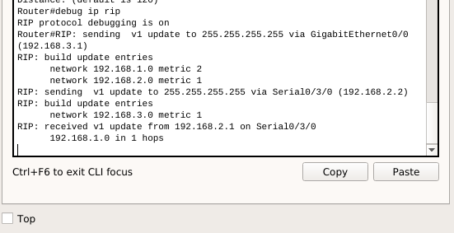

Explain the information shown by the debug command in details.

Rip updates are sent every 30 seconds. We can see that RIP advertise the network through both gigabitethernet and serial. Also, it receives the other network ip addresses through serial0/3/0

**Step 4: Discontinue the debug output with the undebug all command.**

R1#undebug all

**Task 5: Preventing Routing Updates Through an Interface**

Sending updates out this interface wastes the bandwidth and processing resources of all devices on the LAN. In addition, advertising updates on a broadcast network is a security risk. RIP updates can be intercepted with packet sniffing software. Routing updates can be modified and sent back to the router, corrupting the router table with false metrics that misdirects traffic.

The passive-interface command is used to disable sending RIPv1 updates out that interface. When you are finished with the RIP configuration, return to privileged EXEC mode and save the current configuration to NVRAM.

**Step 1: Configure R1, R2 to stop sending updates out their FastEthernet0/0 interface.**



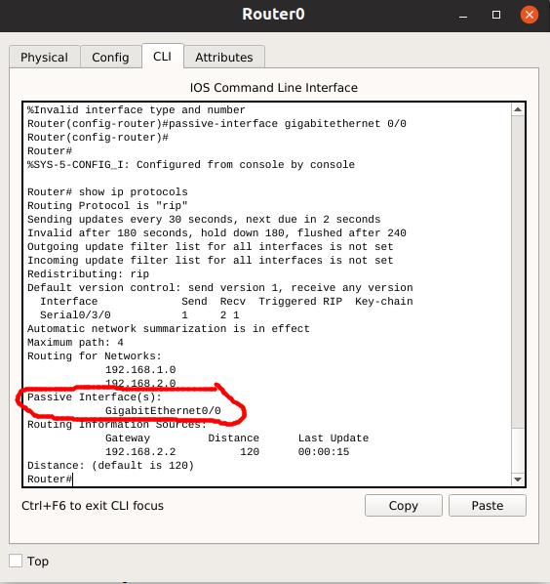

**Task 6: Verify RIP Routing**

**Step 1: Use the show ip route command to verify that each router has all of the networks in the topology in the routing table.**

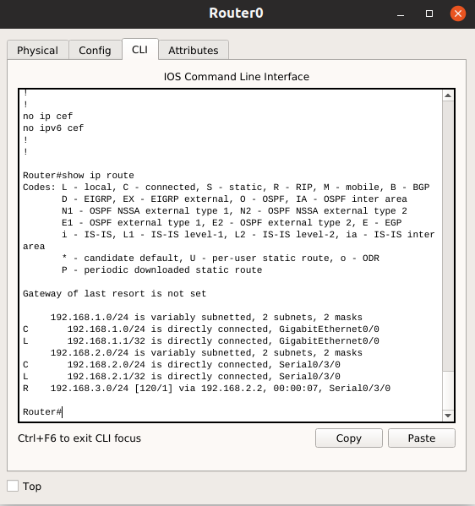

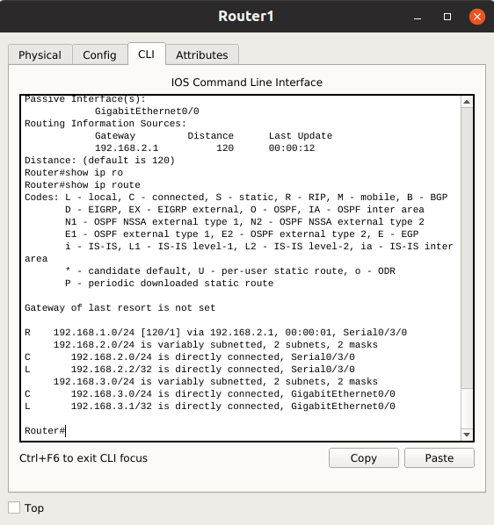

**Step 2: Verify that all necessary interfaces are active.**

If one or more routing tables does not have a converged routing table, first make sure that all necessary interfaces are active with show ip interface brief.

**Router 0:**

**Router#show ip interface**

GigabitEthernet0/0 is up, line protocol is up (connected)

Internet address is 192.168.1.1/24

Broadcast address is 255.255.255.255

Address determined by setup command

MTU is 1500 bytes

Helper address is not set

Directed broadcast forwarding is disabled

Outgoing access list is not set

Inbound access list is not set

Proxy ARP is enabled

Security level is default

Split horizon is enabled

ICMP redirects are always sent

ICMP unreachables are always sent

ICMP mask replies are never sent

IP fast switching is disabled

IP fast switching on the same interface is disabled

IP Flow switching is disabled

IP Fast switching turbo vector

IP multicast fast switching is disabled

IP multicast distributed fast switching is disabled

Router Discovery is disabled

IP output packet accounting is disabled

IP access violation accounting is disabled

TCP/IP header compression is disabled

RTP/IP header compression is disabled

Probe proxy name replies are disabled

Policy routing is disabled

Network address translation is disabled

BGP Policy Mapping is disabled

Input features: MCI Check

WCCP Redirect outbound is disabled

WCCP Redirect inbound is disabled

WCCP Redirect exclude is disabled

GigabitEthernet0/1 is up, line protocol is down (disabled)

Internet protocol processing disabled

Serial0/3/0 is up, line protocol is up (connected)

Internet address is 192.168.2.1/24

Broadcast address is 255.255.255.255

Address determined by setup command

MTU is 1500

Helper address is not set

Directed broadcast forwarding is disabled

Outgoing access list is not set

Inbound access list is not set

Proxy ARP is enabled

Security level is default

Split horizon is enabled

ICMP redirects are always sent

ICMP unreachables are always sent

ICMP mask replies are never sent

IP fast switching is disabled

IP fast switching on the same interface is disabled

IP Flow switching is disabled

IP Fast switching turbo vector

IP multicast fast switching is disabled

IP multicast distributed fast switching is disabled

Router Discovery is disabled

IP output packet accounting is disabled

IP access violation accounting is disabled

TCP/IP header compression is disabled

RTP/IP header compression is disabled

Probe proxy name replies are disabled

Policy routing is disabled

Network address translation is disabled

WCCP Redirect outbound is disabled

WCCP Redirect exclude is disabled

BGP Policy Mapping is disabled

Serial0/3/1 is administratively down, line protocol is down (disabled)

Internet protocol processing disabled

Vlan1 is administratively down, line protocol is down

Internet protocol processing disabled

**Router 1:**

Router#show ip interface

GigabitEthernet0/0 is up, line protocol is up (connected)

Internet address is 192.168.3.1/24

Broadcast address is 255.255.255.255

Address determined by setup command

MTU is 1500 bytes

Helper address is not set

Directed broadcast forwarding is disabled

Outgoing access list is not set

Inbound access list is not set

Proxy ARP is enabled

Security level is default

Split horizon is enabled

ICMP redirects are always sent

ICMP unreachables are always sent

ICMP mask replies are never sent

IP fast switching is disabled

IP fast switching on the same interface is disabled

IP Flow switching is disabled

IP Fast switching turbo vector

IP multicast fast switching is disabled

IP multicast distributed fast switching is disabled

Router Discovery is disabled

IP output packet accounting is disabled

IP access violation accounting is disabled

TCP/IP header compression is disabled

RTP/IP header compression is disabled

Probe proxy name replies are disabled

Policy routing is disabled

Network address translation is disabled

BGP Policy Mapping is disabled

Input features: MCI Check

WCCP Redirect outbound is disabled

WCCP Redirect inbound is disabled

WCCP Redirect exclude is disabled

GigabitEthernet0/1 is administratively down, line protocol is down (disabled)

Internet protocol processing disabled

Serial0/3/0 is up, line protocol is up (connected)

Internet address is 192.168.2.2/24

Broadcast address is 255.255.255.255

Address determined by setup command

MTU is 1500

Helper address is not set

Directed broadcast forwarding is disabled

Outgoing access list is not set

Inbound access list is not set

Proxy ARP is enabled

Security level is default

Split horizon is enabled

ICMP redirects are always sent

ICMP unreachables are always sent

ICMP mask replies are never sent

IP fast switching is disabled

IP fast switching on the same interface is disabled

IP Flow switching is disabled

IP Fast switching turbo vector

IP multicast fast switching is disabled

IP multicast distributed fast switching is disabled

Router Discovery is disabled

IP output packet accounting is disabled

IP access violation accounting is disabled

TCP/IP header compression is disabled

RTP/IP header compression is disabled

Probe proxy name replies are disabled

Policy routing is disabled

Network address translation is disabled

WCCP Redirect outbound is disabled

WCCP Redirect exclude is disabled

BGP Policy Mapping is disabled

Serial0/3/1 is administratively down, line protocol is down (disabled)

Internet protocol processing disabled

Vlan1 is administratively down, line protocol is down

Internet protocol processing disabled

Then use show ip protocols to verify the RIP configuration.

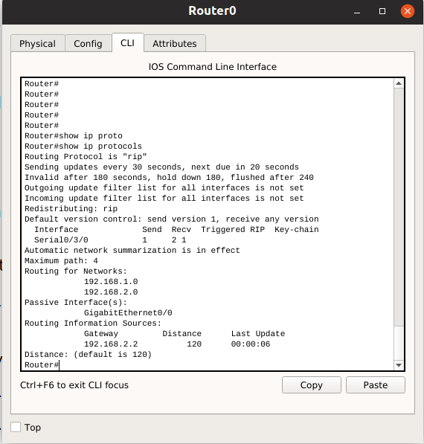

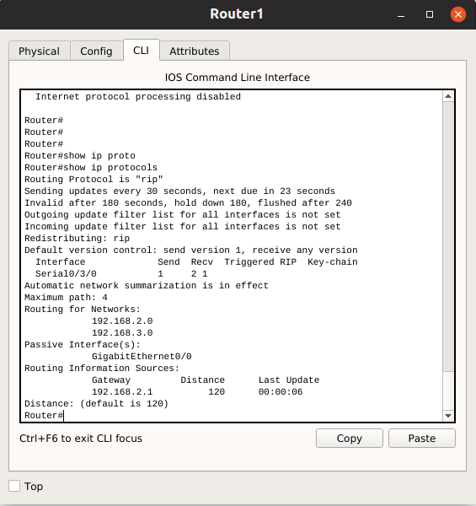

Notice in the output from this command that the FastEthernet0/0 interface is no longer listed under Interface but is now listed under a new section of the output: **Passive Interface(s)**. Please point out in the output.

**Step 3: View the RIP messages being sent and received.**

To view the RIP messages being sent and received use the debug ip rip command.

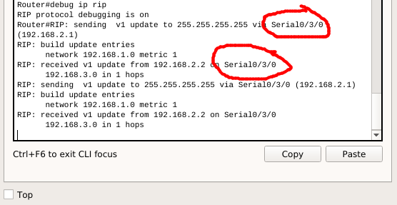

Notice that RIP updates are not sent out of the fa0/0 interface because of the passive-interface fastethernet 0/0 command. Please point out in the output.

After debug, we must use undebug all command.

**Task 7: Running RIP on a Stub Network**

Typically, a company runs a dynamic routing protocol (RIPv1 in our case) within the local network but finds it unnecessary to run a dynamic routing protocol between the company’s gateway router and the ISP. For example, colleges with multiple campuses often run a dynamic routing protocol between campuses but use default routing to the ISP for access to the Internet. In some cases, remote campuses may even use default routing to the main campus, choosing to use dynamic routing only locally.

To keep our example simple, let’s assume that the loop-back interface of router R2 connect to the ISP for our Company XYZ, which consists of the R1 and R2 routers. Company XYZ is a stub network, meaning that there is only one way in and one way out via connection between R2 (the gateway router) and the ISP.

How about traffic from Company XYZ toward the Internet? It makes no sense for ISP to send over 120,000 summarized Internet routes to R2. All R2 needs to know is that if a packet is not destined for a host on its networks, then it should send the packet to the ISP. This is the same for all other Company XYZ routers (only R1 in our case). They should send all traffic not destined for its network to R2. R2 would then forward the traffic to the ISP. The XYZ network is called STUB network.

**Step 1: Configure loop-back interface on router R2 to simulate the connection to ISP.**

R2(config)#interface lo 0

R2(config-if)#ip address 172.16.30.1 255.255.255.255

R2(config-if)#no shutdown

**Step 1: Configure R2 to send default traffic to ISP.**

Configure a default static route on R2 that will send all default traffic—packets with destination IP addresses that do not match a specific route in the routing table—to ISP.

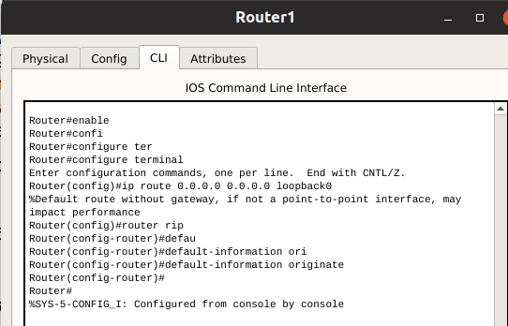

**Step 2: Configure R2 to propagate default static route information to R1.**

The default-information originate command is used to configure R2 to include the default static route with its RIP updates. Configure this command on R2 so that the default static route information is sent to R1.

**Note:** Sometimes it is necessary to clear the RIP routing process before the default-information originate command will work. First, try the command clear ip route * on both R1 and R2. This command will cause the routers to immediately flush routes in the routing table and request updates from each other. Sometimes this does not work with RIP. If the default route information is still not sent to R1, save the configuration on R1 and R2 and then reload both routers. Doing this will reset the hardware and both routers will restart the RIP routing process.

**Task 8: Verify RIP Routing.**

**Step 1:** Use the show ip route command to view the routing table on R2 and R1. If you don’t see the entries with * on both routing tables, maybe you have wrong configuration.

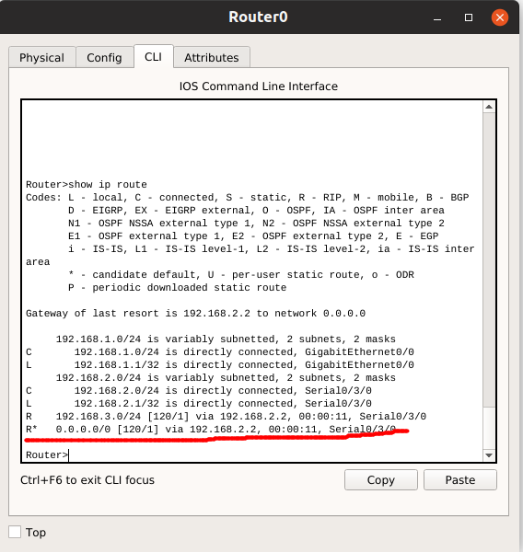

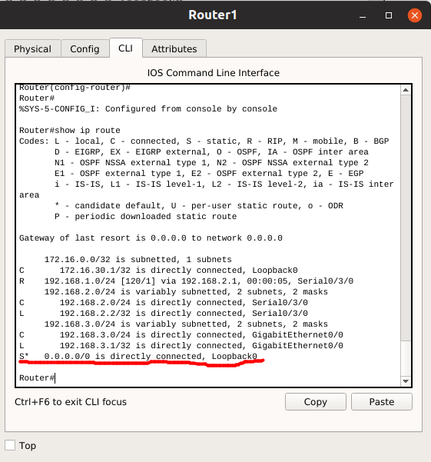

There are some differences in the routing tables between two routers. Please explain the meaning in details.

In router 1, we can see it uses static default ip route to access to the ISP network. On the other hand, in router 0, it uses RIP to route all default ip to the router 1 to go to the ISP

Why we need to propagate the default route to the router inside RIP domain?

We need to propagate the default route to the router inside RIP domain for the other networks to access to the ISP through router 1. If we do not propagate the default route to the router inside RIP domain and we want to access ISP in network router 0, we need to configure the default route by hand. If we have a lot of networks, it is a time consuming job.

**Step 2: View the RIP updates that are sent and received on R1 with the debug ip rip command.**

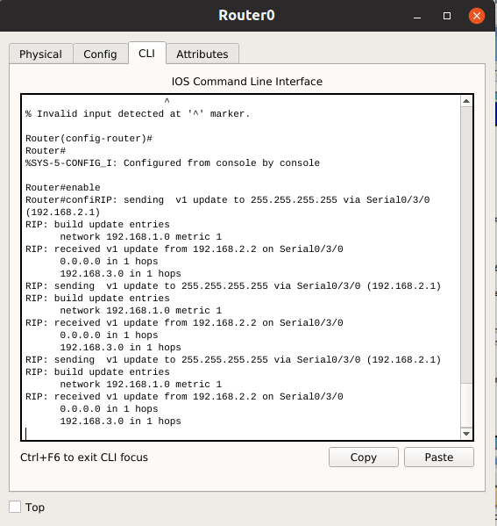

Understanding the output

**Step 3: Discontinue the debug output with the undebug all command.**

**Task 9: Document the Router Configurations**

On each router, capture the following command output to a text file and attaché to your report:

* Running configuration
* Routing table
* Interface summarization
* Output from show ip protocols

**Task 10: Clean Up**

Erase the configurations and reload the routers. For PC hosts that are normally connected to other networks (such as the school LAN or to the Internet), reconnect the appropriate cabling and restore the TCP/IP settings.